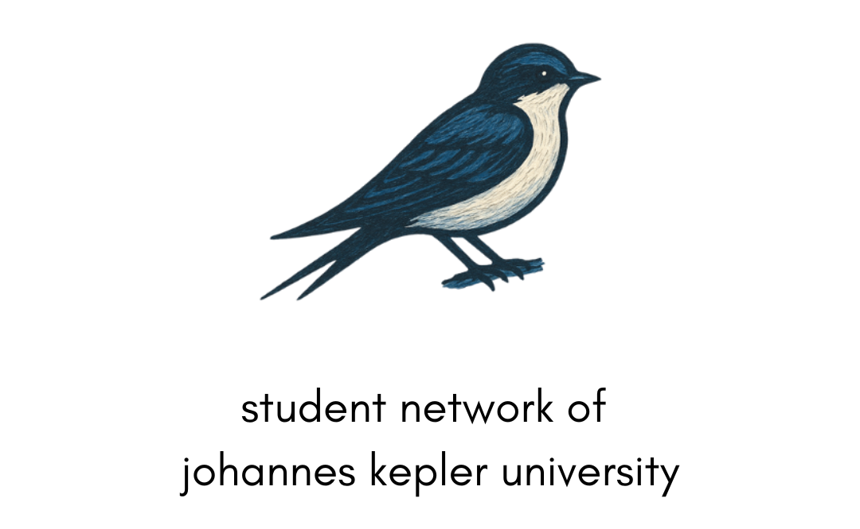

ERASMUS+ PARTNER IDENTIFICATION FORM

A. PARTNER ORGANISATION
OID |  | E10384276
Full legal name (National Language) |  | Mehmet Batuhan Aydin
Full legal Name (English) |  | Student Network of Johannes Kepler University
Acronym |  | SNJKU
Address (Street and number) |  | J. W. Klein Strasse 72/6.ST/34
Country |  | Austria
Region |  | Oberoesterreich
Post Code |  | 4040
City |  | Linz
Instagram |  | student.network.jku
Website |  | www.snjku.com
Email |  | Batuhanaydin1776@gmail.com – office@snlinz.com
Telephone 1 |  | +43 660 217 70 56
B. PROFILE
Type of Organisation |  |  | Informal group of young people
Is the partner organisation a public body? |  |  | No
Is the partner organisation a non-profit? |  |  | Yes
D. BACKGROUND AND EXPERIENCE
Please briefly present the partner organisation. | Our group, Student Network of Johannes Kepler University, is a social initiative founded by active students of JKU Linz with backgrounds in technology, non-formal education, and Erasmus+ projects. We aim to promote digital skills, intercultural dialogue, and youth participation, while empowering young people—especially those with fewer opportunities—to take on new roles within Erasmus+ opportunities. Since our creation, we have participated in multiple youth exchanges and training courses across Europe on themes such as entrepreneurship, sustainability, LGBTQIA+ rights, volunteering, and the European Green Deal. Our members also bring diverse experience from volunteering in Austria, including leadership and facilitation in over 10 educational projects at the Blue Whale Education Center. Together, we combine academic knowledge, youth work expertise, and international experience to design impactful initiatives that foster inclusion, personal growth, and active citizenship.
What are the activities and experience of the organisation in the areas relevant for this application? | Our group has extensive experience in Erasmus+ youth exchanges, training courses, and volunteering activities across Europe. We have worked on topics such as entrepreneurship, sustainability, LGBTQIA+ rights, volunteering, and the European Green Deal. Beyond international projects, our members have facilitated and led more than 10 educational activities in Austria, focusing on digital skills, intercultural dialogue, and youth participation. This background allows us to design and implement projects that combine non-formal education methods with innovative approaches relevant to today’s youth.
What are the skills and expertise of key staff/persons involved in this application? | Our members bring diverse expertise, including youth work, project coordination, digitalization, intercultural communication, and facilitation. Batuhan Aydın contributes experience from over 10 youth exchanges, AI studies, social media management, and facilitation in international projects. Yusuf Fidan adds strong skills in translation, project coordination, social media visibility, and catering for youth projects, combining linguistic expertise with cultural adaptation. Together, our team has the technical, creative, and organizational competencies to ensure the successful implementation of Erasmus+ initiatives.
E. LEGAL REPRESENTATIVE
Title | Mr.
Gender | Male
First Name | Mehmet Batuhan
Family Name | AYDIN
Department | Finance & Administration Department
Position | Legal Representative
Email | Batuhanaydin1776@gmail.com
Telephone 1 | +43 660 217 70 56
Address | Julius Raab Strasse 10 / 3.ST 303
Country | Austria
Region | Oberoesterreich
Post Code | 4040
City | Linz
CONTACT PERSON
Title | Mr.
Gender | Male
First Name | Yusuf Ihsan
Family Name | Fidan
Department | Communication
Position | Main Contact Person
Email | yusufihsanfidan@gmail.com
Telephone | +43 660 238 82 47
Address | Köflacher G. 9
Country | Austria
Region | Steiermark
Post Code | 8020
City | Graz

European Union granted projects\EU programmes 2014-2026
EU programme | Year | Project identification or Contract N | Applicant/ Beneficiary Name
Erasmus+ K152 | 2025 |  | Student Network of Johannes Kepler University / Mehmet Batuhan AYDIN
  2025-1-AT01-KA152-YOU-000300304
Erasmus+ K152 | 2025 | 2025-3-AT01-KA152-YOU-000384735 | Student Network of Johannes Kepler University / Mehmet Batuhan AYDIN
Erasmus+ K155 | 2026 | 2026-1-AT01-KA155-YOU-000392506 | Student Network of Johannes Kepler University / Mehmet Batuhan AYDIN

Please briefly present your group. Please describe also how the group was created.
Our group is a social initiative started by active students of Johannes Kepler University (https://www.jku.at/en/) who have experience in technology, non-formal education, and Erasmus+ projects. A group of young people at our university, interested in digitalization, youth work, and Erasmus+, decided to launch the Student Network of Johannes Kepler University to promote digital skills and knowledge among young people. Additionally, we aim to empower them to take on new tasks and roles within the framework of Erasmus+ opportunities, contributing to their future as well as the future of our society. Our mission is to enhance the active participation of young people, particularly those from vulnerable social groups and those with fewer opportunities. Our group envisions evolving into an active NGO in the future.
Does your group have any experience with youth work? if yes Please describe such experience.
Our group members have had the opportunity to participate in various international youth exchanges and volunteering programs, gaining valuable experience and knowledge that we plan to use in designing future initiatives. Our first youth exchange took place in Serbia, where we explored entrepreneurship, focusing on sales and marketing, idea pitching, and artificial intelligence. The second experience was sports volunteering during the European Universities Games organized by EUSA in Poland (2022). In Slovakia, we participated in a youth exchange about mapping old fruit varieties and their connection to sustainability. In France, we attended a training course on drafting projects for the European Solidarity Corps (ESC). In Belgium (2023), we took part in a youth exchange focused on reusing waste materials to promote the European Green Deal and a sustainable lifestyle. We attended a networking seminar in Finland (March 2023) after establishing our new informal group, the Student Network of Johannes Kepler University. In Spain, we participated in a youth exchange about Rural Queers and LGBTQIA+ rights. A training course in North Macedonia introduced us to using sports as a learning tool. In Croatia, we attended another training course focused on designing volunteering programs. Beyond international projects, our group also has volunteering experience in Austria. We have been active in the Blue Whale Education Center, run by Platforma Generation Europa NGO in Tauchen, where we participated as leaders, facilitators, and trainers in over 10 educational projects, gaining extensive youth work experience.
Please describe the profile of each of the group members and what does each one bring to the project (in terms of competences, experience etc.).
M. Batuhan Aydın was born in Turkey and began his academic journey studying Marine Engineering at Yıldız Technical University. Early on, his path expanded beyond traditional engineering when he became a long-term volunteer with the European Solidarity Corps in Italy - an experience that strongly shaped his international outlook. During this period, he participated in more than 10 youth exchanges across Europe, taking on roles as a coordinator, photographer, and cook, while gaining hands-on experience in intercultural collaboration and non-formal education.
Driven by curiosity and a desire for personal growth, Batuhan backpacked across Europe, immersing himself in diverse cultures and communities. These experiences eventually led him to Austria, where he is currently pursuing a degree in Artificial Intelligence at Johannes Kepler Universität Linz. His academic focus centers on AI and its real-world applications, combining technical problem-solving with a strong interest in societal impact.
Alongside his studies, Batuhan is actively involved in youth work and civil society. He collaborates with multiple NGOs in Austria and across Europe as a youth worker, facilitating international projects, mentoring young participants, managing social media activities, and promoting inclusive and participatory learning environments. In addition, he serves as an Ambassador for Associazione Vagamondo in Italy - the organization where he completed his volunteering - representing the NGO internationally and strengthening cross-border networks. He has also founded an informal student group at his university and successfully implemented youth and education-focused projects.
With a multidisciplinary background spanning artificial intelligence, programming, photography, and communication, Batuhan combines technical expertise with creative skills in his work. He thrives in multicultural environments and is consistently motivated by innovation, collaboration, and the ambition to contribute to meaningful social change at both local and international levels.
Yusuf Fidan is an internationally oriented professional with a multidisciplinary background spanning languages, project coordination, and creative work. He graduated from Bilkent University with a degree in Translation and Interpretation, where he built a strong foundation in language, cultural adaptation, and communication. Following his studies, he began his professional career in the game industry, working as a game localization expert and junior project coordinator, gaining hands-on experience in managing multilingual projects and cross-functional teams.
Alongside his professional path, Yusuf became actively involved in youth work and volunteering. He joined New Wellness Education in Italy as a long-term ESC volunteer, contributing to Erasmus+ projects through project coordination, participant selection, facilitation, and social media visibility. This immersive experience in non-formal education and international cooperation further strengthened his intercultural competence and organizational skills.
During his time in Italy, Yusuf discovered a strong passion for cooking, which gradually evolved into a professional practice. He began catering for international youth projects and events, combining creativity, organization, and cultural storytelling through food. His work as a caterer has since become an integral part of his profile, allowing him to create meaningful shared experiences in multicultural settings.
Yusuf is currently pursuing a master’s degree in English and American Studies at the University of Graz. With a background that bridges language, project work, and culinary creativity, he brings a unique mix of analytical thinking, cultural sensitivity, and practical skills to everything he does. He thrives in international environments and is driven by learning, collaboration, and creating impactful experiences across disciplines.

